**BÀI 1: CÂY ĐỆ QUY**

**Substitution Method**

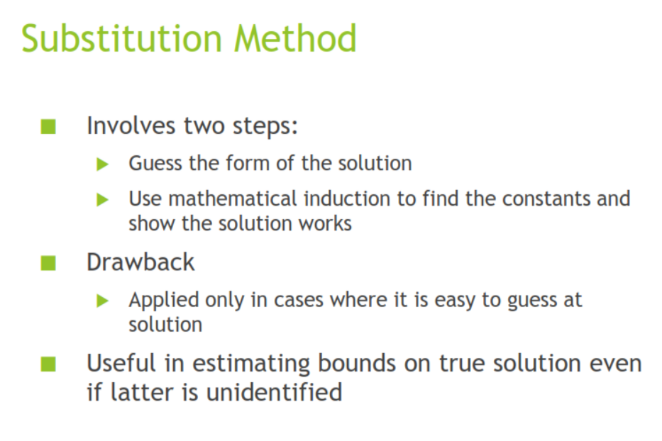

**Recursion Tree Method**

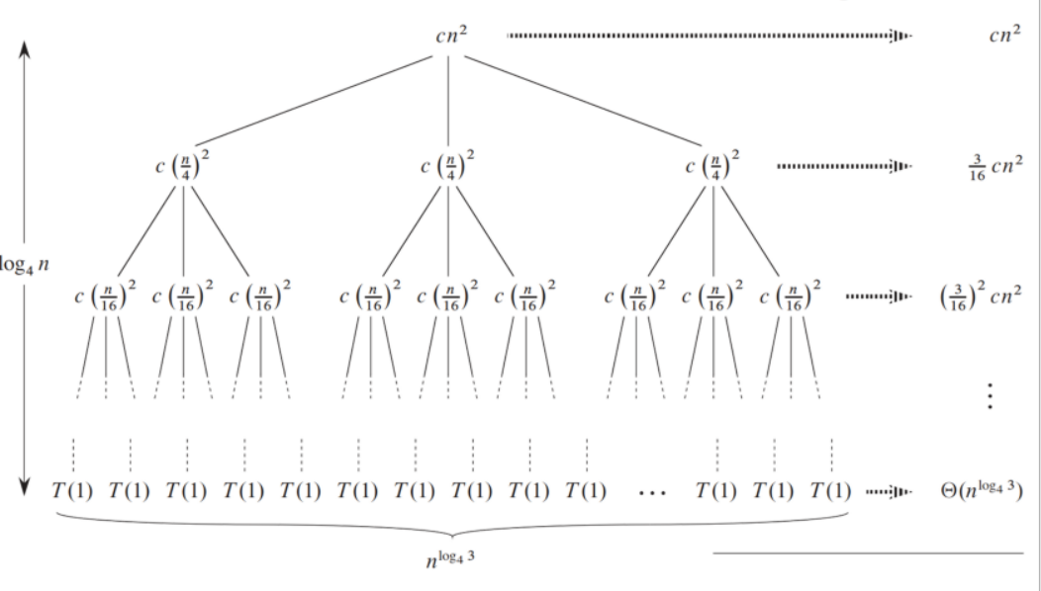

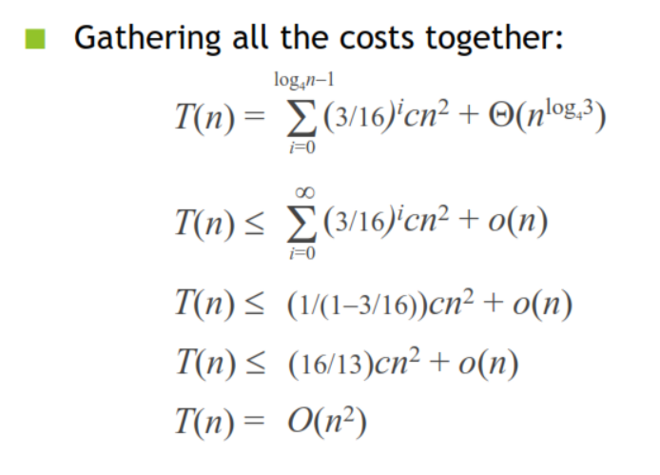

**Master Method**

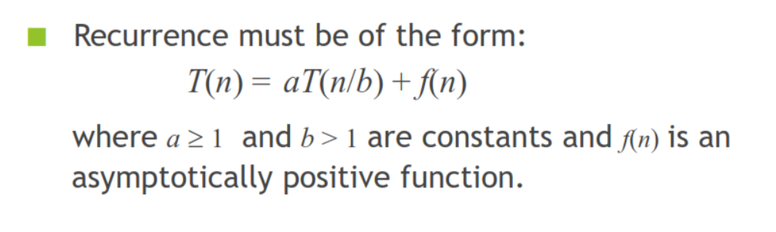

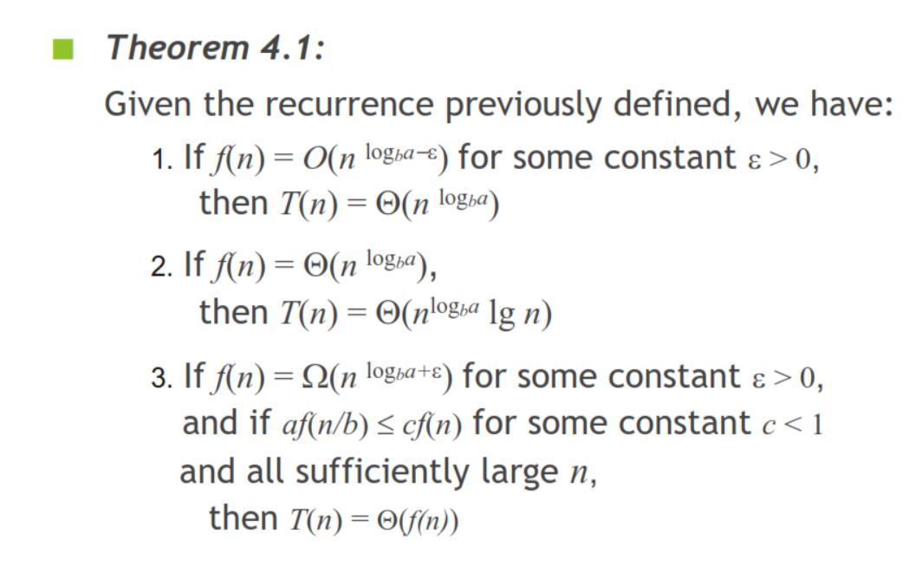

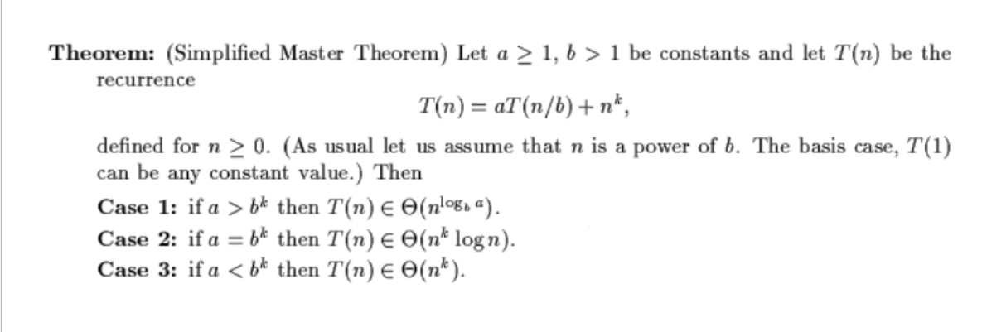

**Bài Tập**

**BT1: T(n) = 2T(n/4) + 1**

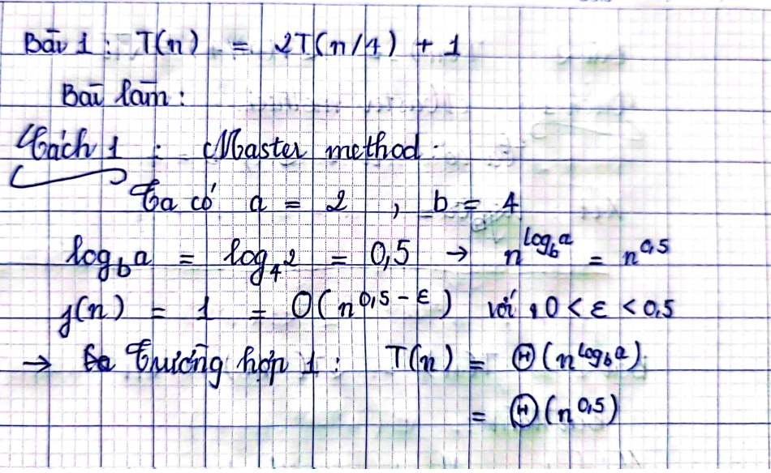

**BT2: T(n) = 2T(n/4) +**

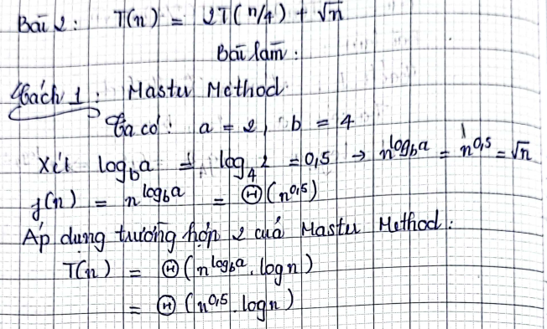

**BT3: T(n) = T(n – 1) +**

